Q.1. Write a Java program to copy a file from HDFS to LFS.

Ans.

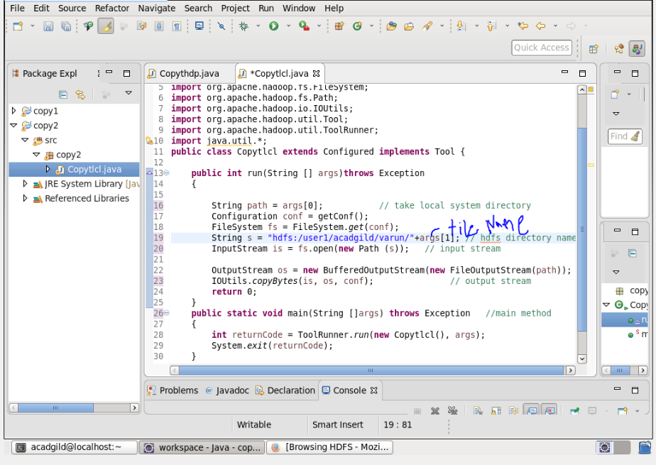

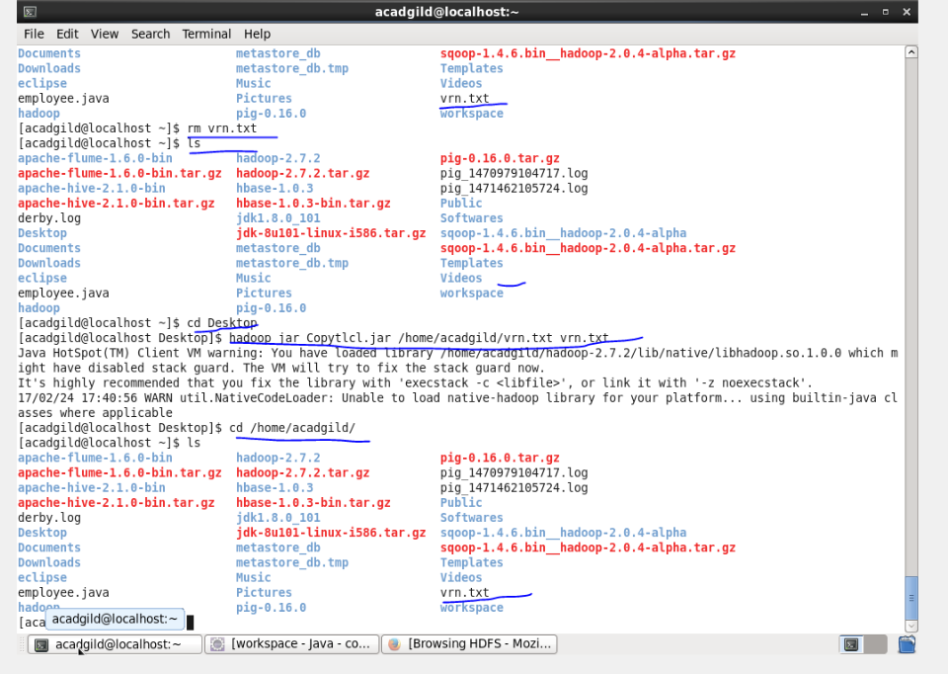

Q.2. Explain the importance and usage of the below terms in details

● DFSInputStream

● DFSOutputStream

● FSDataInputStream

● FSDataOutputStream

Ans:

**DFSInputStream :**

1. Handles communication of the namenodewith various datanodes.

2. Handles integrity of data contained by the blocks.

3. Manages data read activity in case of datanodefailure.

4. Called internally by FSDataInputStream.

**FSDataInputStream :**

It Provides stream (channel) for reading data. FSDataInputStream Lets the application read from a file

FSDataInputStreamin = null;

in = fs.open(new Path(uri));

**FSDataOutputStream :**

Provides stream (channel) for writing data.

OutputStreamout = fs.create(new Path(dst));

IOUtils.copyBytes(in, out, 4096, true);

**DFSOutputStream :**

1. Handles communication of the namenode with various datanodes.

2. Called internally by FSDataOutputStream.